WEEKLY REPORT 2
Week: 12/10 - 18/10

1. Member 1
Fullname: Nguyễn Thị Tuyết Minh.
MSSV: 24127451.

1.1. Done Tasks
- Task 1: Seminar 1: Prepared the script.
- Task 2: Weekly Report 1.
- Task 3: Weekly Report 2.
- Task 4: Rup_sdpln: Implement sections 3 and 4 of the project plan.
- Task 5:
- Task 6: PA1: Synthesize, check, and finalize PA0.
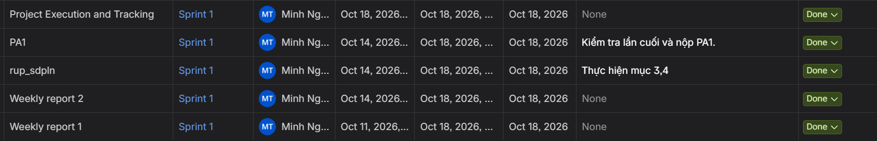

1.2. To Do Tasks
- Task 1: Functional requirements and system scope.
- Task 2: Weekly Report.
- Task 3: PA2: Synthesize, check, and finalize PA2.
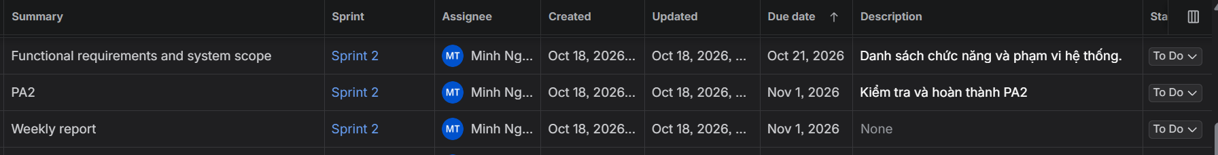

1.3. Issues
- Requirement Refinement: Following Seminar 1, the team identified the need to clarify and supplement certain system details, particularly the scope and functionality of the system's features.
- Schedule Adjustment: The PA1 completion deadline has been postponed by one day to allow the team sufficient time to discuss, align on the revised requirements, and finalize the project scope before proceeding.

2. Member 2
Fullname: Dương Phan Thiên Tú.
MSSV: 24127141.

2.1. Done Tasks
- Task 1: Rup_sdpln: Implement sections 1 and 2 of the project plan.
- Task 2: Rup_vision: Implement sections 1, 2, and 3 of the vision document.

2.2. To Do Tasks
- Task 1: Design initial system architecture.

2.3. Issues
No significant issues this week.

3. Member 3
Fullname: Phạm Phong Vĩ.
MSSV: 24127588.

3.1. Done Tasks
- Task 1: UI prototyping: Create preliminary UI designs for the system.
- Task 2: Rup_vision: Implement sections 4, 5, and 6 of the vision document.

3.2. To Do Tasks
- Task 1: Design initial database model.

3.3. Issues
No significant issues this week.

